**Pup Inflation:**

**Dogs getting higher ratings on cuteness**

There is a significant trend that dogs are getting higher ratings on their cuteness.

This interesting conclusion is drawn from the Twitter account [@dog_rates](https://twitter.com/dog_rates), which is the world’s foremost source for professional dog ratings. The dog rating provided by [@dog_rates](https://twitter.com/dog_rates) is a number out of 10 based on how cute a dog looks.

We scraped the rating data from Feb 14th, 2016 to Sept 6th, 2017 and did some data analysis *(cleaned the data before analyzing to ensure it makes sense, of course)*. Here is a figure showing the rating for every single dog as well as the rating tendency.

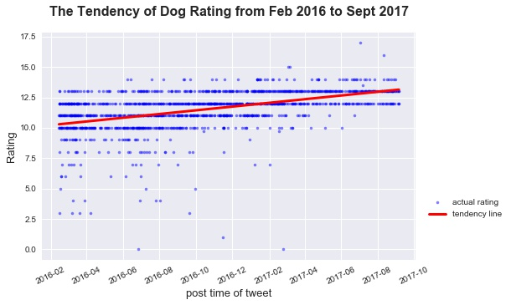

Now it seems that everything is so clear and the grade inflation couldn’t be more obvious. We already get our conclusion and can put down things at here. END…

But, is that true?

Unfortunately, in order to draw a **significant** conclusion, we can’t be such naïve. What if our tendency line doesn’t make sense? we must do some further job to verify our work.

Let’s answer the question that whether our tendency line makes sense. In another word, we need to verify that the tendency line is able to represent the trend of all rating data. I calculated the residuals, which is the difference between actual ratings and the tendency line, and drew out its distribution.

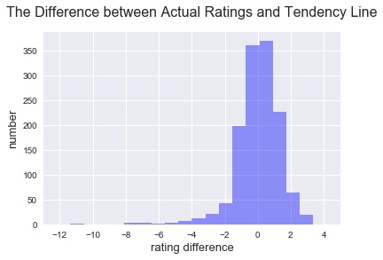

As it’s shown in the figure, most of the residuals fall in the interval of $\left[-2, 2\right]$, an acceptable distance. Thus, it proves that our tendency line indeed represents the trend of all the rating data.

Statistical tests can hand us a helping hand, too. I did the OLS *(i.e. Ordinary Linear Regression)* test and got the p-value as ${7.79×10}^{-77}$. This very small p-value tells us that we can confidently say the trend of rating doesn’t remain the same.

Now it’s the proper time to make the conclusion: dogs are getting higher ratings on their cuteness.

Thanks to Mr. Greg Baker for providing data and technical instructions.